Telemetry technical challenge

Summary
Telemetry technical challenge 1
Requirements 2
Solution 4
RSocket 4
Client 5
Backend 5
Database 6
Frontend 6
How it is working 7
Chronology 7
Scalability and securing 8
Link to application presentation 8
Conclusion 8

Requirements

# Technical Challenge
## Introduction
As a Technical Challenge, the candidate should deliver within the 17th of February, a working Proof-of-Concept of the discussed system.
## Challenge details
1) The candidate should prove its proficency with different languages (C, C++, Rust, Golang are suggested, but the candidate is free to explore other solutions if he/she desires to do so) by building a compiled executable for the OS distribution of his/her choice, that will send information about the Operative System (list of active Processes, CPU and RAM usage) to a different server machine (Backend) via HTTPS. The executable will send this information every X minutes to the Backend, where X is an easy to configure (at building time) timespan.
2) The candidate will choose the technology stack he/she prefers to build a Proof-of-Concept for the Backend, designed to receive the above-mentioned data from the executable. Store the data in the database of your choice. The candidate will motivate the design and technology stack chosen (e.g. performance, scalability etc.).
3) The Backend must be able to communicate with the executable created at point (1) and able to stop the executable execution.
4) Build, a simple UI (e.g. a simple web page), with the technology you prefer, to be able to visualize the information previously collected by the Backend. Furthermore, the UI will provide the user an easy way to activate the (3) functionality.

## Architecture
Here follows a graphic example of the abovementioned architecture:
_________ ________
| Backend | <----------------> | Client |
_________ ________
| |
| |
Ubuntu macOs/Android/Ubuntu/Windows
## Deliverable

As a deliverable, the candidate is expected to be able to illustrate the Proof-of-Concept developed and its architecture.
The candidate should also send the source code of the developed solution.
## Notes
There's no single valid solution to the challenge: its purpose is to evaluate the reasoning behind the technical choices made.
In case of any doubts, feel free to contact us at any time.

Solution
The main functionality in this challenge was the server to be able to stop a client (agent) remotely through a frontend. Without this requirement the architecture can be really more simple.

We could develop a simple client and send over rest API and json content telemetry data to a backend server to be saved in database.

But as we need to have a bidirectional communication it will change the architecture.
I decided to go with sockets. It is a low-level http protocol using TCP or UDP and can be developed in any languages. Then I searched a little on the web and I wanted
to be able to send a command (or a data) from server to any client at any time...
After few time, I discovered rsocket.io, an async socket protocol to be able used with java, kotlin, javascript, Go, .net, C++ or swift language even with JS, it means we can decide what language fit to develop client (and server).

As I am a java backend developer, I naturally decided to develop the client in java language (we can get telemetry data with this technology and to be deployed on any distribution, with dotNet for example it is not possible). Indeed, I will develop it more quickly because we have a deadline and after all it fits all requirements.

RSocket

RSocket is a good technology to keep connection between client and server and to not create a client with webserver to listen connection (too heavy), it makes just more point of failures or some security bottle necks. Although for me there is really a few cases where server must call client... For me it should be not exists like that (except few cases depending needed)

RSocket has implementation in multiples languages. The Java library is built on Project Reactor, and Reactor Netty for the transport. That means signals from Reactive Streams Publishers in your application propagate transparently through RSocket across the network.

Advantages
- Bidirectional communication
- Big community
- Light
- Fit perfectly with problem
- Can be implemented on lot of different technologies
- No need web server
- Secured

Java implementation

The Java implementation for RSocket is built on Project Reactor. The transports for TCP and WebSocket are built on Reactor Netty. As a Reactive Streams library, Reactor simplifies the job of implementing the protocol. For applications it is a natural fit to use Flux and Mono with declarative operators and transparent back pressure support. The API in RSocket Java is intentionally minimal and basic. It focuses on protocol features and leaves the application programming model (e.g. RPC codegen vs other) as a higher level, independent concern.
We can even choose to communicate with web socket. Moreover, if we want to go further we can make communication between front and backend with WebSocket (to keep data on real time).

Client
Client is developed in java and Spring boot but can be developed in any technology we want. Here we create a jar and can be deploying on Windows, Mac or Unix systems (Tested in windows)
Advantages
- Can be deployed on any platform (even mobile) easily as a deamon or agent
- Fast development as we use same lib for backend
- Support less expansive as it is same technology

Backend
For backend side i decided to use Spring boot because it is light serverless and embbed rsocket lib to deploy a scalable server through spring cloud and spring cloud gateway or a loadbalancer) quickly.
With Spring boot we can easily create a webserver with REST api (to deliver some functionalities) and Rsocket server in same time. No lot of configurations needed, fast deployment etc...

Advantages :
- Rest api access, could deliver datas to all technologies or api possible (mobile, desktop etc…)
- With api we can create postman(newman) backend end to end test
- Rsocket is a bidirectional communication technology cans be used with TCP or websocket
- Spring boot serverless abd light server can be installed on all environments (UNIx, WINDOWS)
- No need devops specialist to deploy application (just a jar file)

Database
I decided to use NoSql MongoDB because the schema is simple and can fit with one document (collection), mongo DB have no integrity constraint and no schema (we can easily change or telemetry datas to send without update database DB etc...)

Advantages
- No schema
- No integrity constraint
- Document type data
- Light and fast use

Frontend
For the frontend Side I will develop a Vuejs3 and Quasar frameworks. First because i am training myself on those technologies, and because it fits perfectly with the case, a light web application with REST API calls. Moreover, Quasar is a UI designing tools and let developer to create beautiful UI without UX designer help.

Advantages
- Fast development
- Reload OnFly
- Websocket possible
- Easy to deploy
- Multiplateform
- Beautiful
- New technologies
- Quick learning

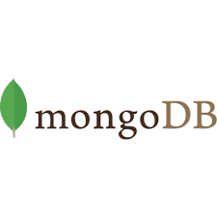 |  | 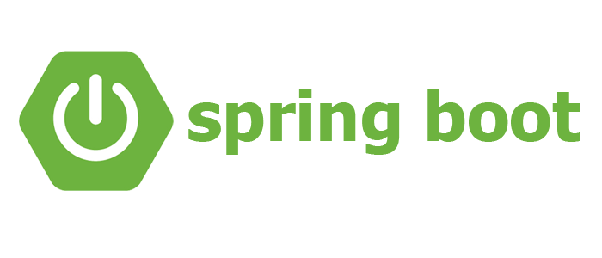 | 
https://vuejs.org/
https://www.mongodb.com/
https://quasar.dev/
https://spring.io/

How it is working
Client will prepare a SETUP connection (server can authorizes or not client to send data)

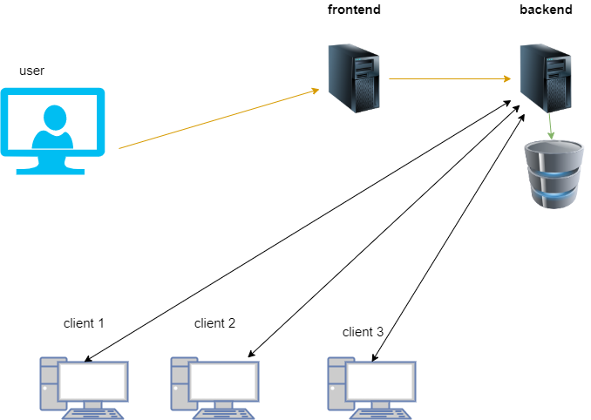

Chronology

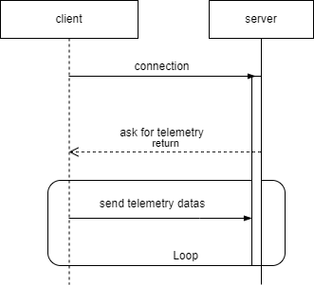

Screens
Frontend no client connected

When client connected
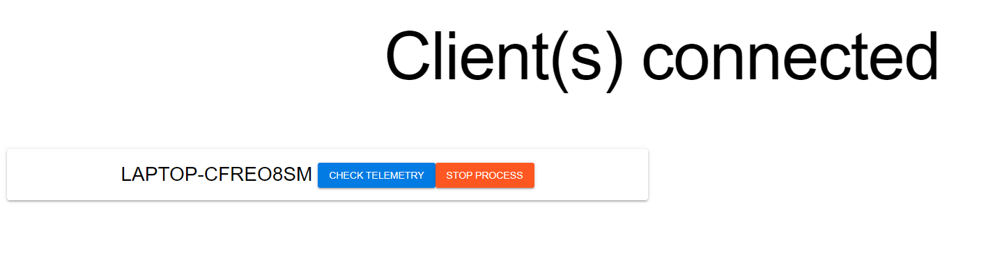
Multiple clients connected
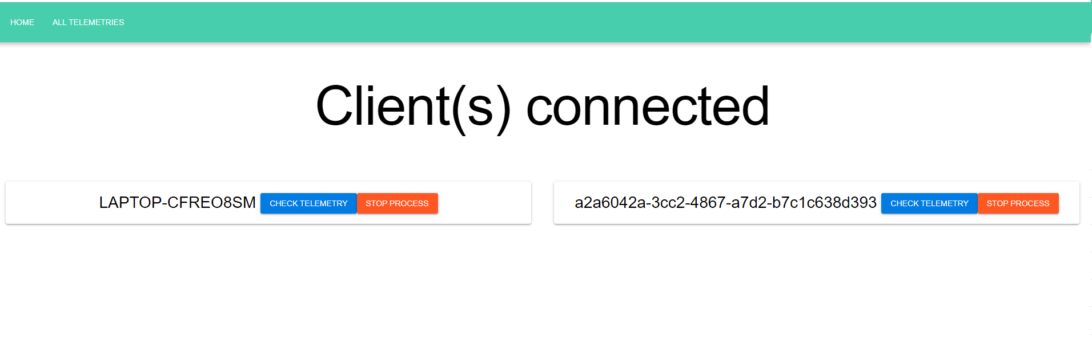
Client telemetry
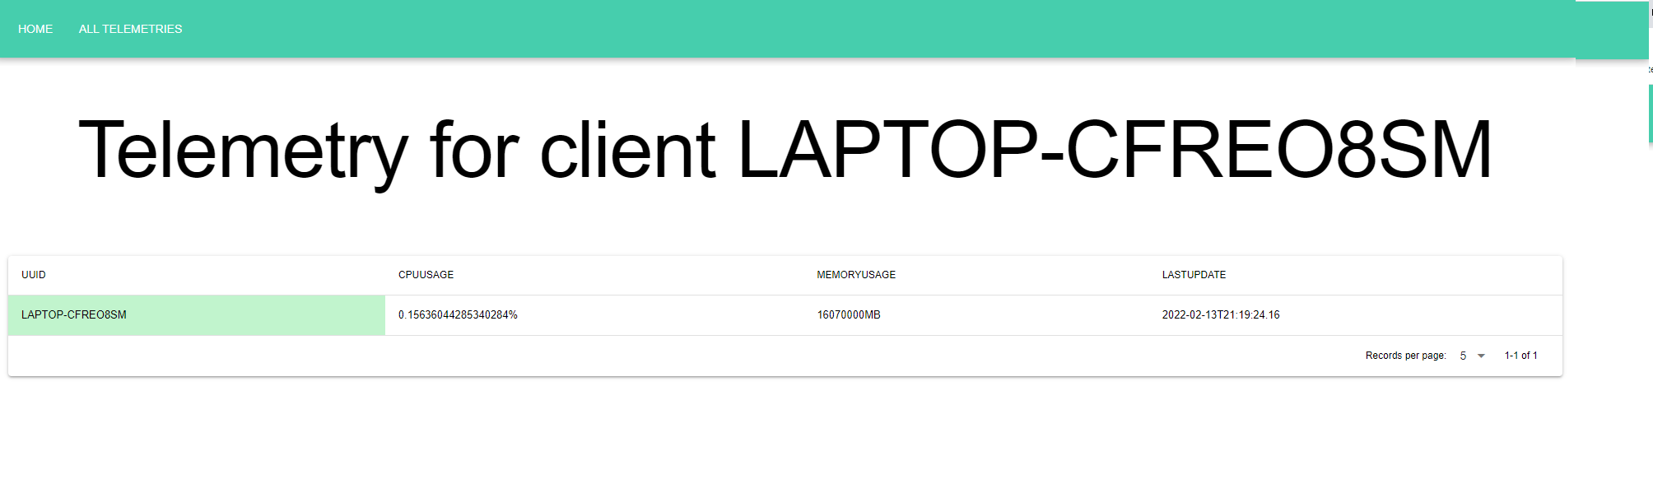
Actives processes
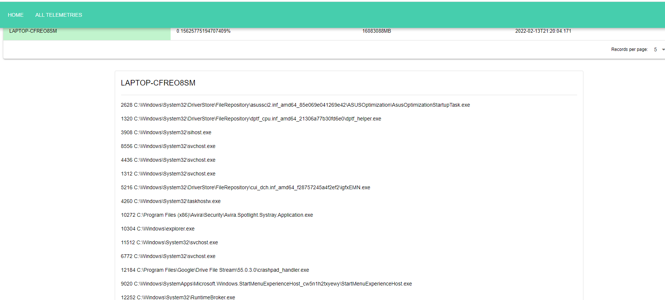
All telemetries
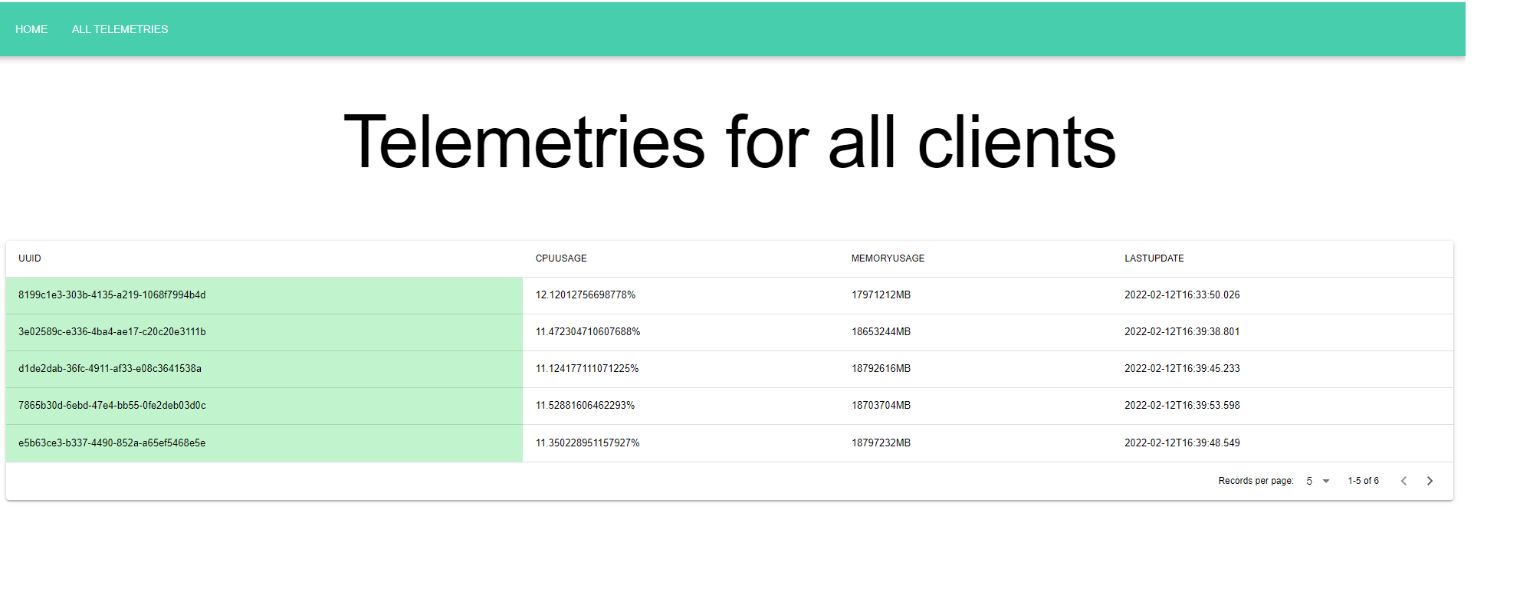
Specific client telemetry
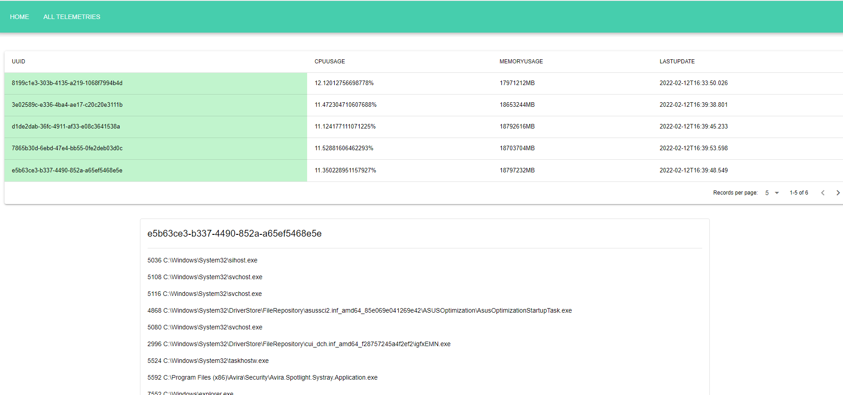
Database representation
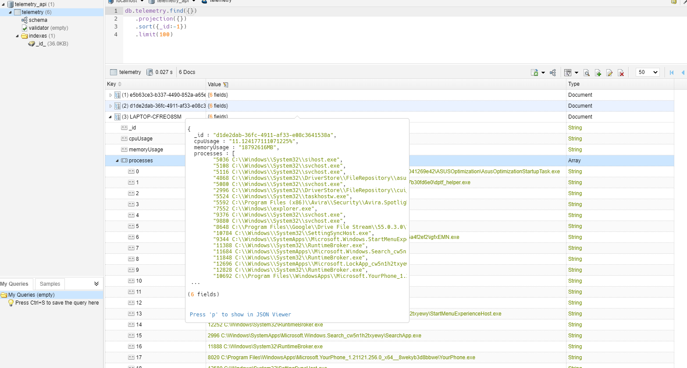
Once at least one client is connected

Scalability and securing
We can use loadbalancer for RSocket and Spring cloud for backend side
For security we can use https for rest API but also for Rsocket connection
We can set rights on client to connect to server (Rsocket) and we off course make login for frontend web page
Mongo and vuejs3 are easily scalable too.

Link to application presentation
https://watch.screencastify.com/v/QRcRPFwjvI9rJC3waAMr

Conclusion
Finally, the stack was chosen following my skills, my knowledges and off course requirements (after technological watch)

It is really nice because permits to develop something with no lot of persons (System, Development, production etc...), and need few support skills (JAVA / JS)
We can deploy all applications on docker to make it more automatized (my tests was made on Mongo DB with Docker)

